STEP 1 START

STEP 2 Store the element to delete.

STEP 3 If front == -1 then Queue Underflow.

STEP 4 Element deleted from queue is cqueue_arr[front].

STEP 5 if (front==rear) then front= -1; rear= -1; else goto

step 6. STEP 6 if (front == MAX - 1) then front= 0 else goto step 7.

STEP 7 front = front + 1.

STEP 8 STOP

1. Front=-1 then underflow and exit.
2. If front ==rear

Q[front]=NULL

Then front=-1,rear=-1.

1. If front==max-1 then

Front=0

Item=Q[front]

Q[front]=NULL

Else

Item=Q[front]

Q[front]=NULL

Front=front+1

1. Exit.

|  |  |  |  |  |  |
| --- | --- | --- | --- | --- | --- |
|  | B |  |  |  |  |

0 1 2 3 4 5

Front=1

Rear=1

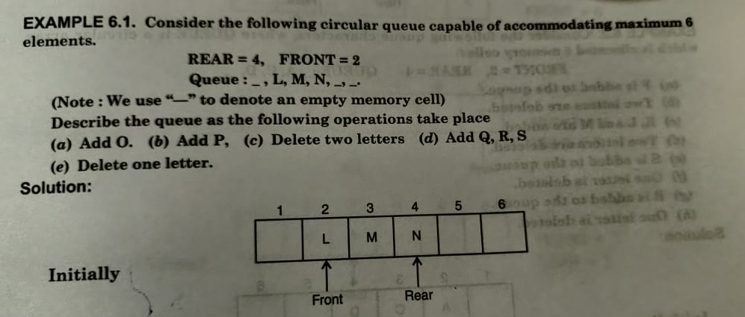

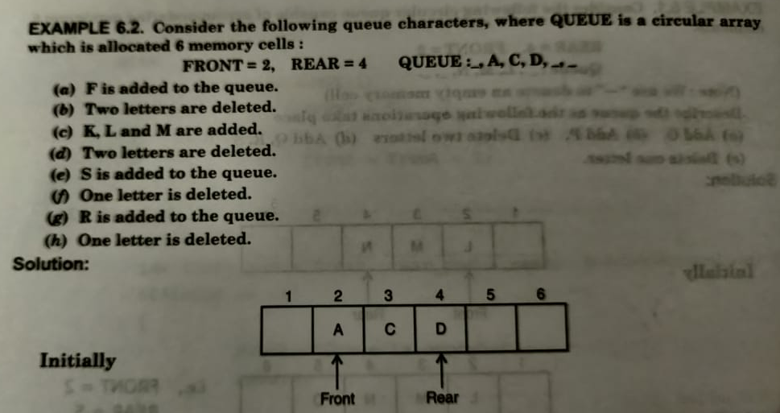

1. Overflow
2. Take the item
3. Rear=rear+1
4. A[rear]=item
5. K=rear
6. Repeat step number 7 k>front

If A[k-1]<A[k]

Perform swapping

k--;

1. exit

temp=A[k]  
A[k]=A[k-1]

A[k-1]=temp

Q. create algorithm for ascending and descending priority queue for insertion.